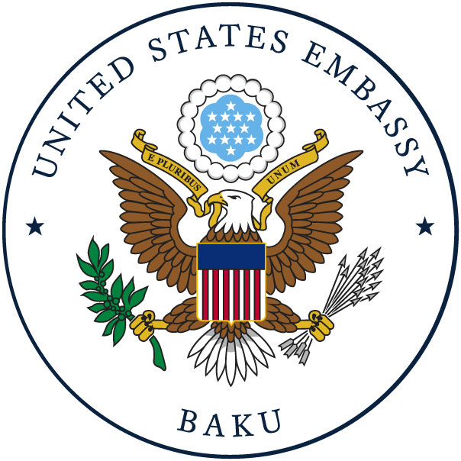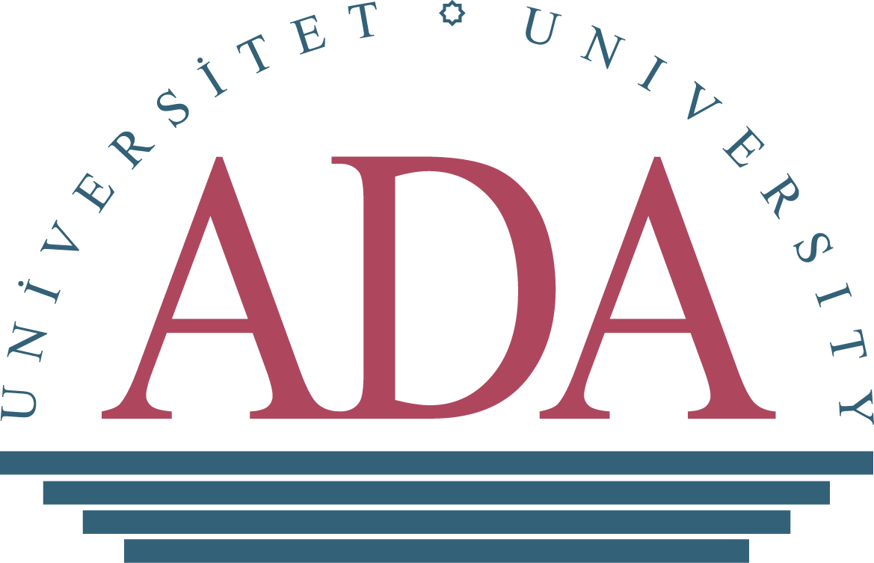

CALL FOR COURSE PARTICIPATION:
GENERAL ENGLISH AND RESEARCH-BASED COURSES

ADA University is pleased to announce a Call for Course Participation in the “Enhancing Research Culture in Azerbaijan” program funded by the U.S. Embassy in Azerbaijan. Designed for non-native speakers of English, the project will help researchers from the regions across Azerbaijan improve their English language skills necessary for reading and producing academic papers in English, as well as for increasing their accessibility to scholarly literature in English.

This program is primarily intended for graduate and postgraduate students, independent researchers, young faculty members from regional higher education institutions and think-tank organizations, particularly in the field of social sciences and humanities across a wide spectrum of disciplines (political science, sociology, philosophy, history, education, law, economics, gender studies, public policy, etc.)

The overall objective of the program is to contribute to the country’s agenda on reforming academic inquiry field and increasing international competitiveness of higher education institutions, by developing local scientific community and increasing the visibility of researchers in Azerbaijan and worldwide.

The project will introduce a wide range of semester-long courses on “General English” (1st stage) and “Research Methods; Statistical Analysis; Academic Writing” (2nd stage). The General English courses will help participants enhance their ability to read, research, and improve their oral expression and listening skills. The duration of the courses in each stage is four months. The “General English” course will be divided into two sections: Listening- Speaking (40 hours) and Reading- Writing (40 hours).
Please note, only participants who successfully complete the first stage and improve their English language proficiency will be eligible to pass to the second stage. The courses in the second stage are Social Research Methods (40 hours), Statistical Analysis (40 hours), and Academic Writing (25 hours) that will be delivered online in English.

Leading professors from the ADA University will deliver the courses, trainings, and academic mentorship. Project participants will have to follow course requirements and fulfill all course assignments. Upon the completion of the courses, successful applicants will be awarded a Certificate of Completion.

How to apply

ADA University seeks MA and Ph.D. students, postdoctoral fellows, junior faculty, and researchers from the regions to apply by filling the application form at the following link:

https://forms.gle/2bAoDEGsHSPfttCG9

Elementary and/or pre-intermediate level of English language is required.

Applications should be completed no later than November 10, 2022. Incomplete applications will not be considered. Shortlisted applicants will be invited to an interview.

