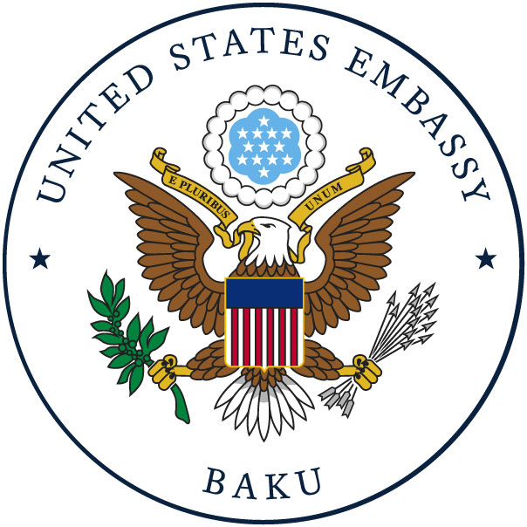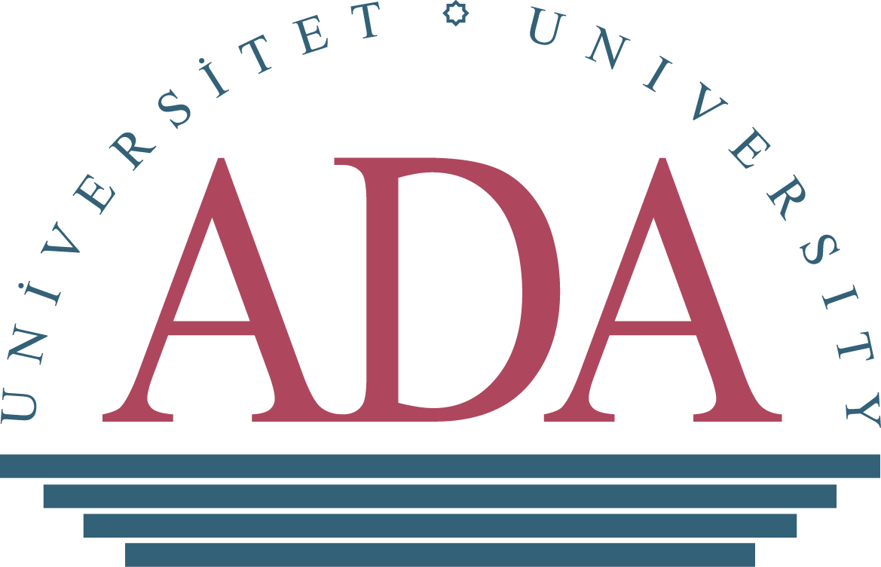

CALL FOR COURSE PARTICIPATION

ADA University is pleased to announce a Call for Course Participation in the “Enhancing Research Culture in Azerbaijan” program funded by the U.S. Embassy in Azerbaijan. These semester–long, inquiry-based courses, aiming at enhancing research potential of the country are primarily intended for graduate and postgraduate students, independent researchers, young faculty members from various higher education institutions and think-tank organizations, particularly in the field of social sciences and humanities across a wide spectrum of disciplines (political science, sociology, philosophy, history, education, law, economics, gender studies, public policy, etc.)

The overall objective of the above-mentioned project is to contribute to the country’s agenda on reforming academic inquiry field and increasing international competitiveness of higher education institutions, by developing local scientific community and increasing the visibility of researchers in Azerbaijan and worldwide.

The project will introduce a wide range of semester-long research -oriented courses and short-term training programs on “ Social Research Methods” ( 40 hours), “Academic Writing”(25 hours) and “Statistical Analysis”( 40 hours) necessary to support and encourage project beneficiaries to produce high-impact academic papers in the field of social sciences to be publicized at international, regional and national workshops and conferences, as well as policy papers to provide decision-makers with an overview of an issue or problem, targeted analysis, and actionable recommendations.

Leading professors of ADA University will deliver the courses, trainings, and academic mentorship. The project participants will have to follow all course requirements and fulfill all course assignments. Upon the completion of the courses, successful applicants will be awarded with the Certificate of Completion.

How to apply

ADA University seeks Ph.D. and MA students, postdoctoral fellows, junior faculty, and researchers to apply by filling the application form in the following link:

https://forms.gle/fyxEPLCsY4YZtWdW8

English language proficiency is required.

Applications should be sent no later than November 10, 2022. Incomplete applications will not be considered. Shortlisted applicants will be invited to online interview.

